**Everything there is to know about components - Angular**

**The structure of a component –**

Any component should be composed from number of parts, the first part is the *component-name*.component.ts file, this file will have an import of the component from the angular/core, a component selector that gets an object that contains kind of important data to the component and export of the component as a class. It looks like that:

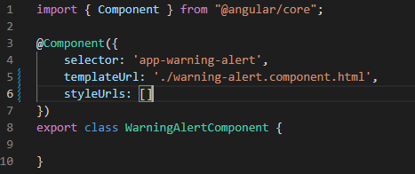

**selector –** it’s the HTML tag that we will use when we want to use our new component. The selector mechanism is like the css one, but selecting by ID or pseudo selector won't work.

**templateUrl / template –** the actual HTML code that we insert into the component and will be shown whenever we use the new component we are creating. If we want to use a file we will choose - templateUrl else for inline HTML style we will use - template.

**stylesUrl/styles –** same as the template selector but only with CSS.

**How to create a new component?**

There are 2 ways to create a new component, manually or with the CLI, let's go through them:

**The manual way:**

In this way, we will create the files ourselves, first of all lets create a new folder inside our app folder, the folder name will be our component name. Example: warning-alert, inside that folder lets create these files: warning-alert.component.ts/html/css in each of them we will find only the relevant pieces of code as we expect by the file name.

After that, we should import our new component to the app.module.ts file to the declarations array.

**The CLI way:**

we can you the following commands:

ng generate component *component-name* / ng g c *component-name*.

**Component Lifecycle:**

Inside the export class we can see that our new component implements OnInit, and has a constructor. Inside the constructor, we can write code that will run at the point of time when this component is being created by Angular.